To apply for Membership:  Visit www.ridcalliance.com / email: ridcalliance@gmail.com  Phone:  Visit us on Facebook  BOARD MEMBERS:  Dr. Raymond Voller, Kaur Dental of Fox Chapel  Carm Acre, Thar Process, Inc.  David McNaughton, Evolutionary Fitness  Dr. Kiran Kauer, Kaur Dental of Fox Chapel  Cynthia Kenderson, Thar Process, Inc.  Lindsy Bartoleit, Cook MyoSite  Frank Gentile, Evergreen Facility Services  Greg Carpenter, Synergy Media Group  Ciara Macioce , RIDC of Southwestern PA  RIDC Business Alliance membership directory sign  [Company Name]  [Street Address]  [City, ST ZIP Code] |  |  | JOIN THE ALLIANCE TODAY!  A non-profit, non-political, non-sectarian organization,  the RIDC Business Alliance is comprised of business leaders and  representatives from O’Hara Township’s RIDC Park,  located just outside of Pittsburgh, Pennsylvania.

Through one unified voice, the alliance promotes business development by building relationships, networking and striving for a clean, aesthetically pleasing and healthy working environment within the suburban-Pittsburgh park.  RECYCLING EVENTS (RIDC ALLIANCE/ASCENTDATA)  MEET & GREET EVENTS  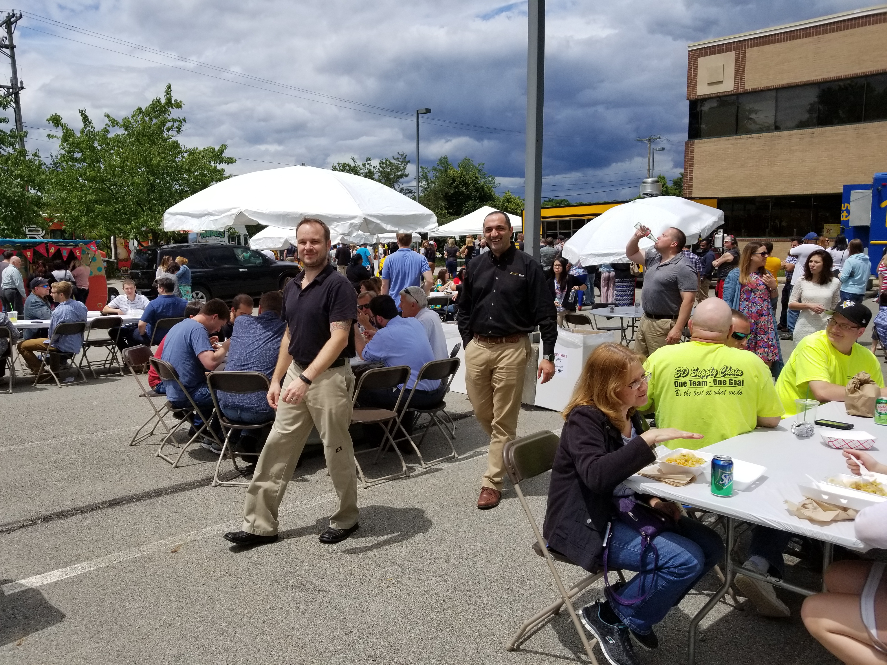  FOOD TRUCK EVENTS |  |  | WHY BECOME A MEMBER  Our growing list of benefits includes:  Exclusive listing on our directory sign, which is located in a high traffic area on Gamma Drive  Advocacy for the business community  A clean, aesthetically-pleasing and healthy Working environment and quality of life  A greater savings in purchasing and services  Promotion to outside business interests  A unified resource to gather and disseminate information and opportunities  Promotion of progressive business relationships among members  Recent accomplishments include:  Bus Service  Walking Path  Township Relations

